TECHIN512 Lab 1 Instrument Familiarization

**Introduction**

The purpose of this lab is to learn to use the electronic instruments provided on your lab bench.

**Background**

This is an intro lab to get you up to speed on our instruments. It also serves to introduce you to the basic lab write-up format.

**Your Oscilloscope Probe**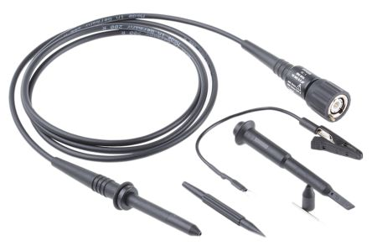

Your scope probe is more than a wire. Your scope probe is actually a sensitive instrument for making measurements with the oscilloscope. We will cover the theory of ‘scope probes later in the quarter. The scope probe is somewhat delicate and you should treat it with care. Rough handling can break it and cause unreliable measurements. It is easy to forget about this and to get confused about a circuit when in fact the problem is a broken probe. To keep your probe in good condition:

* Only connect your probe to the inputs at the bottom of the oscilloscope, never to anything else. (Although this probe is compatible to the signal generator, it should never be connected to a signal generator)
* Try not to pull hard on any part of your probes or bang them around. *Handle with care!*

The base of the probe is a circular twist-on-lock twist-off-lock connector referred to as a “[BNC](https://en.wikipedia.org/wiki/BNC_connector)” type connector. It makes a firm connection but never requires high force. Glide it onto a BNC jack and twist it clockwise to lock, twist counter clockwise to unlock. The BNC method was an innovative improvement over the very old [Type F](https://en.wikipedia.org/wiki/F_connector) threaded connectors (think cable TV!) which required a lot of twisting. 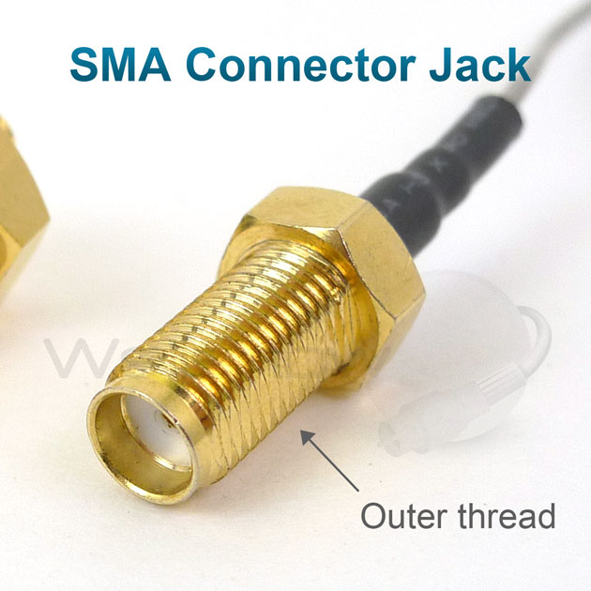

**10X probes**

Your probe may have a little switch labeled “**10X - 1X**”. Switch this to “**10X**” **for all TECHIN512 labs**. To provide a more accurate measurement over a wide range of frequencies, “10X” oscilloscope probes divide the voltage at their tip by 10 before sending it in to the oscilloscope (using a voltage divider naturally!). Internally, the scope can multiply the voltage by 10 so that voltages are displayed correctly. For example, suppose you measure +12V with a “10X” probe. The ‘scope actually sees +1.2V but, **if it is set up properly**, it will multiply that voltage by 10 so that +12V will be displayed. However the scope can also be used with regular cables as inputs which are simply wires and do not divide by 10. Therefore they need both modes. The reason for this odd setup will be explained in lecture when we cover the theory of ‘scope probes (which are a nice example of some of the key circuit concepts we will cover).

**Resources**:

* Tektronix PWS2185 DC Power Supply [ [User Manual](https://download.tek.com/manual/071275100web.pdf) ]
* Tektronix DPO2004B Oscilloscope [ [User Manual](https://www.tek.com/oscilloscope/mso2000-dpo2000-manual-0) ]
* Tektronix AFG2021 Arbitrary Function Generator [ [User Manual](https://www.tek.com/signal-generator/afg2000-function-generator-manual/afg2021-1) ]
* Fluke 87 V True-RMS Multimeter (“DMM”) [ [User Manual](https://dam-assets.fluke.com/s3fs-public/80v_____umeng0200.pdf?tKDGTic.KN0dP9_UJVtSyLsuYWEUp3SY) ]
* Standard Issue GIX electronics tool pouch, probes, and cables

**Write-Up**

The writeup for this lab should contain the following outline:

1. Title page (see template in the folder ‘Requirement of Lab Reports’)
2. Introduction   
   ⅓ of a page describing the purpose and goals of this lab *in your own words.* **Do not reproduce any material from this assignment document in any section of your writeup.**
3. Results  
   Each location in the instructions below **marked with “>” i**ndicates some data which must appear in your report. Separate each result or related set of results with a section header indicating what it is. For any numerical data or graph describe the meaning of the data.
4. Discussion and Conclusions:

* In ½ to 1 page, summarize the key learning points from the Results above.

**Preparation**:

Pre-lab computations:

* None

Parts, tools, supplies required: instruments provided on your lab bench:

1. Oscilloscope and probe
2. Power Supply
3. Signal Generator
4. BNC-to-BNC Cable, BNC-to-clips cable, black and red test leads for DMM

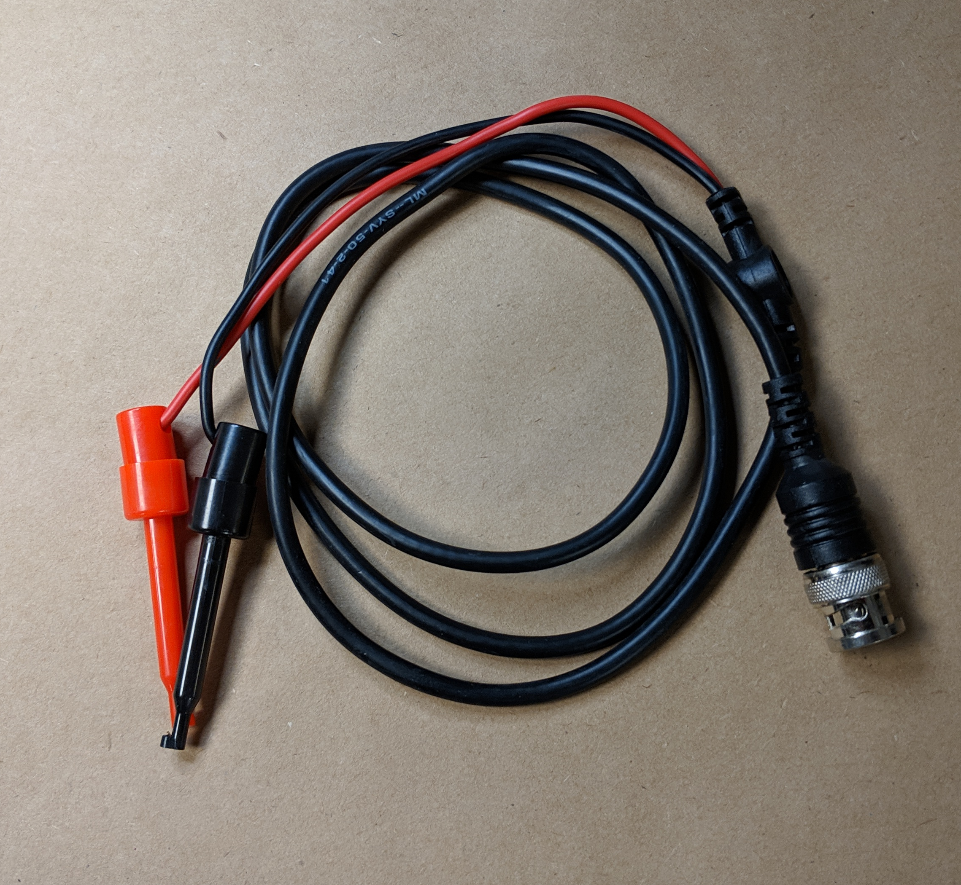

BNC - to clips cable

￼

1. Yellow-hand held Fluke DMM
2. Resistors: 47 Ohm, 1000 Ohm

**Procedure**:

### Power -

1. Locate horizontal power switch on edge of lab-bench-shelf and turn it on. It should light up (but dimly)
2. On each instrument, locate it’s “power-on button” and turn it on.
3. Annoyingly, they require a bit of time to start up.
4. Locate your yellow hand-held DMM and plug in its test leads. Black lead must be in “Common”/”COM” and Red lead in “VΩ...” (red jack in lower right corner). Set dial to DC Voltage Mode ().

### DC Voltage

1. Set the DC power supply to put out +4.75 Volts: 1) press V-set 2) type 4.75 3) press Enter 4) press the button labeled: “On/Off”
2. On the power supply output terminals, connect a short wire between ‘-’ and GND
3. Set the DMM to DC-Voltage mode ()
4. Touch the DMM black lead to GND and red lead to +
5. > Draw a diagram of your setup
6. > Verify that the DMM reads +4.75 V.
7. Pressing I-set and entering a value can set the maximum current protection. This can help protecting your circuit from short cutting.

### DC Current

When you measure current with a DMM, the current must flow THROUGH the DMM via one of the special current measurement inputs (“A” and “mAuA” below).

|  |  |
| --- | --- |
|  | A = Amperes = “Amps” (current)  mA = “milli Amps” = 10^-3 Amps  uA = “micro Amps” = 10^-6 Amps |

**Important note: You can DAMAGE the DMM in current mode** if the current is not limited by a circuit. Think of the DMM as: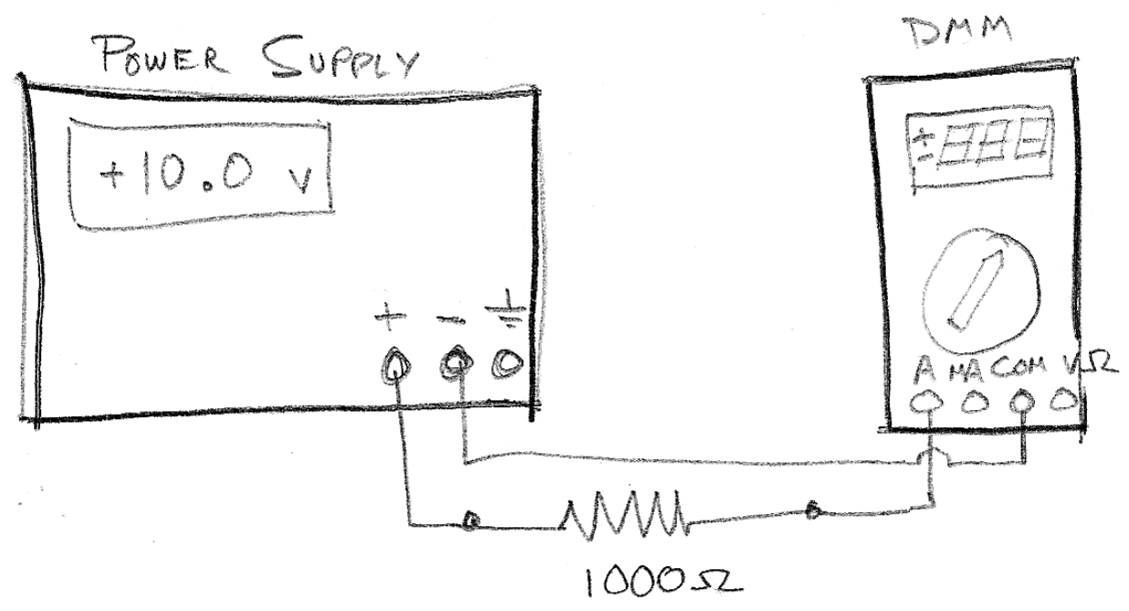

* Voltage mode: an infinite resistor (no current flows)
* Current mode: a 0 Ohm resistor.

**Example**: The circuit shown at right is correct! The resistor in series limits the current through the DMM. If you replace the resistor with a wire (0 Ohms), the current is I = V/R = 10.0/0 = infinite!! The DMM has fuses that blow for safety (and yes we can fix them, it’s just a hassle.)

There are two current inputs to the DMM , “A” (for bigger currents) and “mA/uA” (for smaller currents). For currents up to 10 Amp use the LEFT-most jack ( “A”) for the red lead. You should use “A” most of the time. The only reason to use the “mA/uA” jack is if you need higher accuracy for small currents (<<1A). Verify that your current is < 400mA through the “A” jack before using the “mA/uA” jack so that you do not accidentally blow its sensitive little fuse.

1. Set the DC power supply to 10V.
2. Connect a 1000 Ohm (1K Ohm) resistor between + and GND on power supply.
3. Record the current reading on the power supply.
4. Disconnect resistor from GND.
5. Remove the red lead from the DMM and plug it into the **“A”** (Amps) input of the DMM
6. Set the DMM to measure current: ()
7. Set the DMM to DC mode (toggle AC/DC back and forth with yellow button in upper left). Verify DC mode on LCD display. (this only has to be done for current).
8. Connect the red lead from the DMM to the 1K resistor and the **black** lead from the DMM to GND on power supply. It should now form a loop:
   1. Power supply (+) to 1K resistor
   2. 1K resistor to DMM (+)
   3. DMM **black** lead (-) to Power supply (GND)
9. > Draw a diagram of your setup
10. > Record the current reading on the DMM.
11. If the current reading is smaller than 400mA, reconnect your red lead to “mA/uA” and > record the reading again. > Compare.

### Oscilloscope – Probe Setup

1. Look at the BNC base of your probes and locate a small hole containing a screw head with a crossed slot (this is not a Phillips screw, but actually two crossed slots).  
   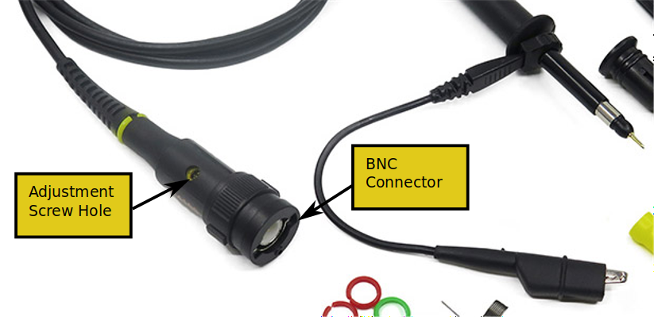
2. Connect your two probes to scope inputs 1 and 2 (yellow, blue).
3. One at a time, press the colored button (1-yellow … 4-green) for each of your probes (typically 1,2). Then using the screen buttons (along bottom) press “probe setup” and set to “10X” (along right side). This sets your scope to work with your 10X probes.
4. Locate the probe calibration connection points in the lower right corner of the ‘scope front panel next to “Aux In”. (metal loops labeled GND and “probe comp”)
5. Connect the ground clips of both scopes to “GND”
6. Connect both probes to “probe comp”
7. Press “AutoSet”
8. Adjust **Vertical** (yellow and blue) **Position and** **Scale**, and **Horizontal Position and Scale** so that
   1. Both waves fill the screen,
   2. Exactly one cycle shows on screen
   3. The two colors are superimposed.

If necessary, adjust the trigger mode (via trigger menu) and trigger level (via knob) to stabilize the waveform on screen.

1. > Capture a screenshot using your cellphone or the ‘scopes built-in screen capture.
2. Using a small screwdriver, adjust the crossed screw on each probe until both waveforms on screen appear to be perfectly rectangular … You have calibrated your probes!
3. > Capture a screenshot using your cellphone or the ‘scopes built-in screen capture.
4. Disconnect your probes

### Signal Generator & Oscilloscope / Visualize a Signal

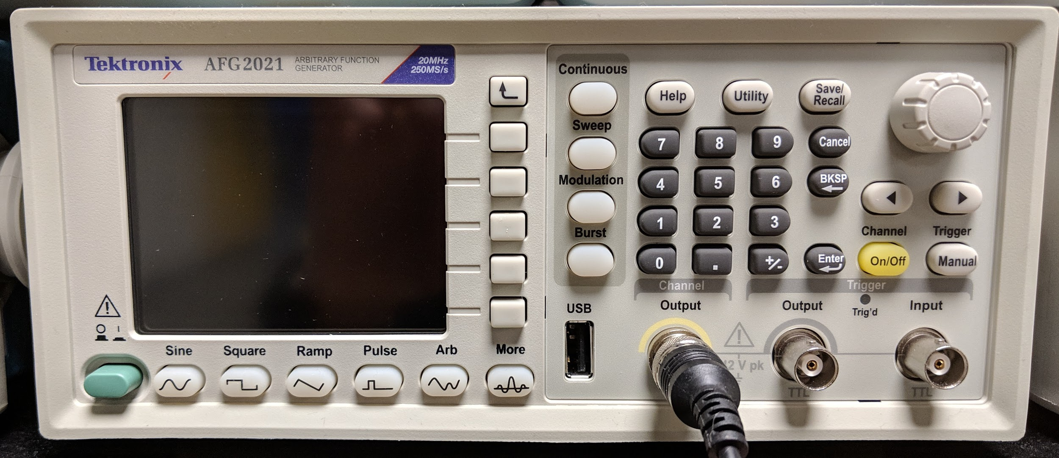

1. On the oscilloscope, connect a BNC-to-BNC cable to the left most (yellow) input on the bottom of the ‘scope front panel.
2. On the signal generator, go to the settings and set ‘load’ to ‘High Z’, which means that the signal generator is expecting a high resistance (the oscilloscope)
3. Connect the other end of the BNC cable to the “Channel / output” jack of the signal generator
4. Navigate the signal generator menus to create the following signal:
   * Waveshape: Ramp
   * Peak-to-peak amplitude: 2.5V
   * Minimum voltage: 0.0V
   * Frequency: 100kHz (1.0E05 cycles per second)
5. Press the “Autoset” button on the ‘scope.
6. On the ‘scope, use the “Horizontal Scale” knob to set the time scale to 4 micro-sec per division
7. > Capture a screen shot with your phone.
8. > Count the number of positive peaks on the screen, and explain why you get the number you get.
9. > Read and record the Peak-to-peak amplitude and minimum voltage.
10. Again using the scope’s “Horizontal Scale” knob, change the time scale to 1 micro-sec per division
11. > repeat steps 7 & 8.
12. Replace the BNC-to-BNC cable with a BNC-to-Clips cable, connecting the BNC jack to the signal generator “channel” output. And go to signal generator and change the ‘load’ to ’50 ohm’.
13. Connect a 50 Ohm resistor between the cable clips.
14. Connect one of your oscilloscope probes to the first (yellow) scope input.
15. Connect the probe across the 50 Ohm resistor
16. > Capture a screen shot with your phone.
17. > Read and record the Peak-to-peak amplitude and minimum voltage. You may need to navigate the oscilloscope menus to add measurements. If you stuck here, please go to TA for help.
18. Retain this setup for the next experiment.

### Signal Generator / Waveforms

1. Verify equipment is connected as in steps 12-15 in the previous experiment.
2. Generate the signals W1-W4 in the table below, and set the ‘scope to
   1. Show 2 cycles of the waveform
   2. Stabilize the waveform

* for signal W4, you may need to navigate the signal generator to change the ‘duty’ setting

1. > Record the settings (horizontal scale, vertical scale, trigger mode*) needed
2. > capture a screenshot of each one.

|  |  |  |  |  |
| --- | --- | --- | --- | --- |
|  | **Shape** | **Frequency** | **V PtoP** | **Vmin** |
| W1 | Square | 1.0 Mhz | 0.50 V | -0.25V |
| W2 | Sine | 1000 Hz | 1.5V | 0.0V |
| W3 | Ramp 50/50 | 200 khz | 3.0V | -1.5V |
| W4 | Pulse: 5% on 95% off (duty) | 1 Mhz | 3.0V | 0.0V |

* Trigger mode: Trigger is to stabilize a repeating signal, or to trigger on a single event. Trigger is like a threshold, when the value of the signal passes the trigger value (increasing or decreasing, according to your setting), the oscilloscope will capture the signal and output it on the screen.